**Travel case study**

**A major cruise line bounces back using AI-powered accelerators**

to manage pent-up travel demand after COVID-19 and improve the overall journey experience

[Image Placeholder]

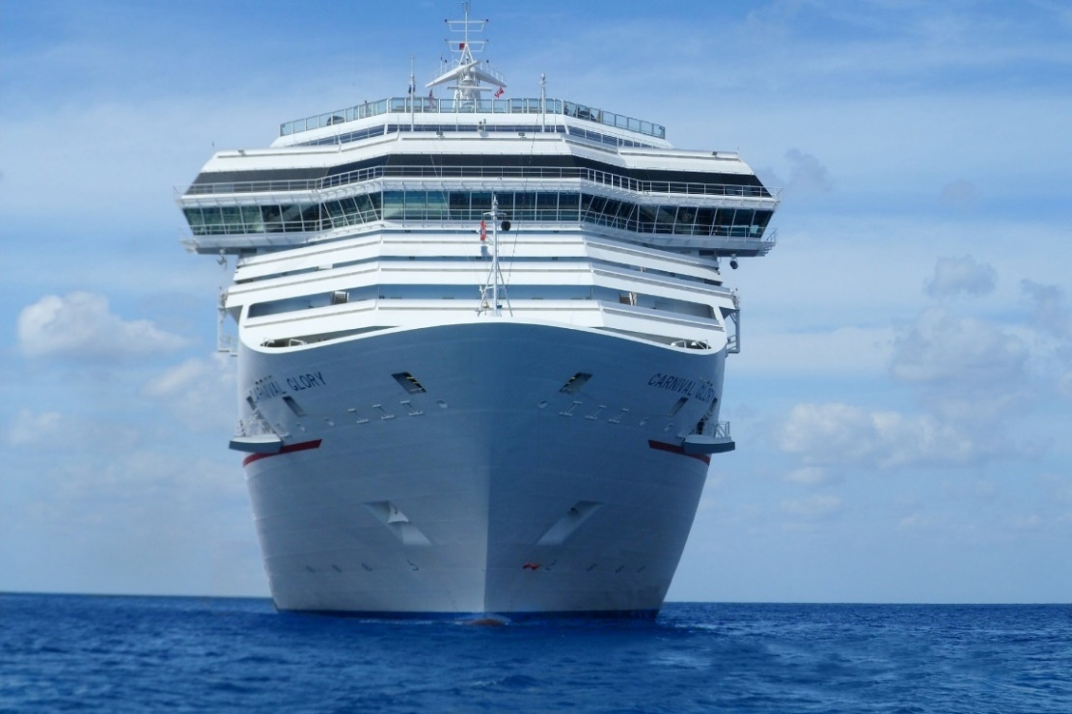

# A pivotal point in time

Countless cruise vacations were put on hold, or canceled altogether, during the COVID-19 pandemic. Many ships were forced to suspend operations for extended periods of time. However, once travel restrictions were lifted, the demand for cruises skyrocketed, presenting a new challenge, i.e. how to process all the incoming customer data.

A major cruise line anticipated pent-up demand of over 40 million customers. This warranted a more robust customer data platform (CDP) to better manage the growth in market size. It was an ideal opportunity for the fourth-largest cruise operator in the world—controlling approximately 8.6% of the total worldwide share of cruise passengers pre-pandemic—to become a bigger player. But first, customer personas had to be identified for a more targeted marketing approach via preferred communication channels to capture the attention of savvy consumers.

Shifting focus to the customer’s journey experience was key to understanding current trends in the travel and hospitality industry. It was also important for the cruise line to take more data ownership and gain more control of analytics for hands-on, rapid response to a fast-paced market. Tredence drew upon prior experience in journey analytics to address existing pain points and recommend proven, self-service technology solutions that would deliver the desired outcome at this pivotal point in time.

# A strategic, value-added approach

Tredence was commissioned to help the cruise line reimagine its business model and meet the growing demands of the post-pandemic era—as customers returned in droves to partake in missed cruises or book new ones. The strategy was to add value by combining state-of-the-art technology tools and partnerships necessary for an enterprise-level digital transformation heavily focused on journey-based marketing. Tredence solution accelerators (AI- and ML-driven) and the well-known Salesforce CDP software are at the core of this vast data modernization effort.

## Collaborating with the cruise line team

Tredence experts worked closely with the cruise line team to fulfill the following business objectives:

* Customer-centric campaign operations
* Data harmonization / single view of customer
* Customer journey consolidation and prioritization
* Marketing orchestration via multi-tech stack
* Holistic, full-funnel marketing measurement

## Shifting to a customer-centric mindset

A paradigm shift in corporate culture was the first step. The cruise line organization needed to transition from mass marketing to a customer-centric mindset to be successful. This new way of thinking was essential to grapple with the diversity within a 40+ million customer database, containing hundreds of terabytes of data and growing. Legacy systems were simply not up to the task. It would take qualified data engineers with similar project expertise, scalable AI/ML accelerators, and a self-service CDP platform to fully meet the enormous data management requirements.

The identification of customer and journey segments, via Automation Studio, was a critical part of the overall change strategy to target potential cruise-goers in a meaningful way. Easy access to centralized reports in Salesforce was also important to make informed marketing campaign decisions.

**CHALLENGES:** Significant data processing gaps in the cruise line’s gathering and utilization of journey intelligence, orchestration of marketing/technology tools, and measurement of campaign results via standardized reporting.

**SOLUTIONS:** Partnered with Salesforce for an easy-to-use, self-service data management platform and customized its modules to suit the cruise line’s business needs. Leveraged the high-performance computing capabilities of the Salesforce Marketing Cloud (SFMC) for faster, scalable data processing. Also used Automation Studio within SFMC to create types of journeys. Set up a customer preference center through a 3P partnership. Implemented a centralized orchestration app and further unified marketing data to measure short- and long-term campaign results.

**RESULTS:** Provided a unified data model to scale across three brands, enabling cross-channel and cross-campaign reporting to inform business decision-makers about what works best and to optimize communication touch points based on experimentation. Increased client independence by having its own in-house CDP with endless, data-driven analytics possibilities.

|  |  |  |  |  |  |
| --- | --- | --- | --- | --- | --- |
| **200+** customer KPIs identified | **50+** key journeys set up in Automation Studio | **$8M+** budget savings from unified campaign operations | **+15%**  average improvement in ROI through precision targeting | **5x** improvement in turnaround time for campaign setup | **150+**  lifetime self-serve users in journey orchestration |

## Harmonizing data for single view of the customer

Tredence guided the cruise line through an agile process of enterprise data preparation. This iterative procedure involved exploring, combining, cleaning, and transforming raw data into curated datasets for self-service data integration.[1] It effectively accomplished harmonization of the cruise line’s multiple source systems, mismatched metrics, and multiple brands. It made all customer profile data available for easy retrieval and faster processing than ever before via Tredence’s AI/ML accelerator solution. It was also a crucial step that helped create a single, 360-degree view of the customer—for easy access, quick online display, big data analytics, and standardized reporting.

**CHALLENGES:** Lack of a foundational data model to capture relevant customer information from different source systems. No common metric definitions across brands and no business rules to differentiate between brands. No built-in data protection in the face of growing cybersecurity risks worldwide. Slow data ingestion speeds. Tedious manually performed jobs needing to be automated. Disparate data requiring aggregation for simplified reporting and online viewing.

**SOLUTIONS:** Harmonized customer data and metrics, including the design of a multilevel data model to unify and store Customer 360 information in one place. Standardized metrics across brands, while also creating business rules to capture brand-specific nuances. Added encrypted, country-level security for the safe sharing and storage of business-critical data. Identified products for ID resolution and customer ID unification across all brands.

**RESULTS:** Achieved a faster rate of data ingestion from source systems, enabling a much higher volume of data to be processed. Aggregated data views for easier reporting at both the brand and country levels. Automated many jobs via SAP Data Services and Informatica Intelligent Cloud Services, resulting in significant cost savings for the client. Unified customer ID data, delivering the capability of anonymous, cross-brand matching.

|  |  |  |  |
| --- | --- | --- | --- |
| **200+** customer features providing 360° omnichannel visibility | **20** brands of schema replication to achieve scale | **~250 TB**  volume of data processed every week | **+35%**  anonymouscustomer matching using ID resolution |

## Consolidating and prioritizing the customer journey

It’s all about the customer journey these days. According to Gartner, “The fusion of marketing, experience, and behavior are emerging around the world.”[2] Tredence applied the science of journey analytics to help the cruise line gain a better understanding of customer behavior and enhance the journey experience—from the moment of marketing. Both journey segmentation and prioritization were employed, along with customer profile categories, to determine the most appropriate methods and channels to reach a given population. This aided the effort to precisely target different segments by express preferences, such as communication touch points. To achieve another cruise line goal of improving customer lifetime value (CLTV), a model was created, and scores were tracked to measure progress.

**CHALLENGES:** No standard definition of “journey,” no clear segmentation of different types of journeys, and no prioritization of journeys within each segment.

**SOLUTIONS:** Created a journey definition framework, which included customer persona and intent with booking start and end rules, as well as communication touch points. Segregated journeys based on macro hierarchies or categories, such as intent, brand, and budget. Further segregated similar journeys by customer profile, touch point, and channel outreach. Prioritized journeys within segments for intervention using brand and channel preferences, as well as CLTV model scores.

**RESULTS:** Optimized journey analytics to provide deeper insights into customer behavior patterns around booking cruises, pinpointing the most appropriate marketing and communications methods for a given segment. For example, delivered the capability to use segmentation and prioritization data to best communicate to customers with a high luxury score combined with a high email marketability score.

|  |  |  |  |
| --- | --- | --- | --- |
| **15**  macro journey segments created at the brand-group level | **5%** average increase in key journey conversions after consolidation | **$115+** average CLTV improvements on prioritized journeys | **Enriched**  metadata for journey analytics and optimization |

## Orchestrating the marketing effort in a digital world

The cruise line was in need of a central data repository and data governance, in addition to personalized marketing campaigns. Use of multiple stacked technologies, e.g. combining Salesforce and the Tredence LEAF data model, delivered Customer 360 data for optimized, self-service queries. Other specialized products, including Content Builder and Automation Studio, enabled personalized, journey-based marketing design and efficient scheduling for concurrent delivery via select digital channels. This orchestrated marketing style increases customer engagement by catering specifically to each group and avoiding a constant stream of annoying messages.

**CHALLENGES:** No data governance, lack of central customer data repository, and no efficient way to personalize marketing campaigns that target diverse audiences.

**SOLUTIONS:** Configured journey rules within Salesforce using the Calculated Insights and Segmentation feature, gave marketers self-service access to modify the rules, and unified data extraction via segment. Built multichannel activation connections for SFMC, Adobe Target (Digital), and LiveRamp for paid media. Scheduled data extract loads, including personalization inputs, for all channels. Modularized content personalization using Content Builder and curated content selection via Automation Studio.

**RESULTS:** Delivered the ability to easily extract audience data, cater to a particular group of customers, and design personalized marketing campaigns—all contributing to faster, simpler design, setup, and simultaneous delivery across multiple marketing channels.

|  |  |  |  |
| --- | --- | --- | --- |
| **User-friendly**  journey  governance system with real-time activation | **15+**  marketing channels activated concurrently | **130+** customer journeys configured and managed in SFMC | **5x**  faster turnaround for campaign design and setup |

## Data mining past marketing results for future success

The cruise line wanted to empower marketers to innovate and experiment with ways to further increase customer engagement—and even attract churned customers—by giving them the freedom to measure, learn, and replicate previous “winners.” User access was granted to historical campaign data for analysis, tracking, and reporting of factors that contributed to holistic marketing performance and high earnings. The goal was to amplify marketing results and return on investment (ROI) with each new campaign.

**CHALLENGES:** No organization-wide framework for measuring and tracking customer health (i.e., customer lifetime value, or CLTV), making it difficult to reconcile reporting across brands and deepen customer engagement.

**SOLUTIONS:** Unified campaign-specific measurements across the enterprise, as well as agencies and brands. Generated scenarios to estimate marketing spend, understand the return on ad spend (ROAS), and optimize the budget for a given customer audience.

**RESULTS:** Provided a 360-degree view of campaign performance to easily identify opportunities for transitioning customers to other brands in the cruise line portfolio. Enabled marketers to study successful campaigns and apply lessons learned to target a similar audience. Improved cruise revenue by decreasing churn/reactivating churned customers.

|  |  |  |  |  |
| --- | --- | --- | --- | --- |
| **100+** campaigns optimized for multiple categories | **1.5%**  average ROI improvement | **20M+** churned customers  reactivated | **>$50M**  optimized in annual season budget spend | **9%**  reduction in cost metrics for digital ads (CPC, CPM, and CPI) |

# Conclusion

This CDP modernization project prepared the cruise line to confidently operate post-pandemic while facing an onslaught of returning and new customers. The application of AI/ML accelerators, along with supplementary tools and services, streamlined the client’s overall data analytics and the journey-based marketing process in particular.

Marketers now have the information they need to successfully launch segmented cruise campaigns via digital channels. Early results indicate improved ROI as data-driven innovation and experimentation continue to evolve. In this case, data ownership and self-service access were definitely the way to go.

Want to know more about us? Please visit <https://www.tredence.com/industries/travel-hospitality>.

1. Gartner Glossary, “[Data Preparation](https://www.gartner.com/en/information-technology/glossary/data-preparation),” accessed March 2023.
2. Gartner, “[Digital Edge In Marketing: The Customer Experience in ‘real time’](https://blogs.gartner.com/mark-mcdonald/2013/01/28/digital-edge-in-marketing-the-customer-experience-in-real-time),” January 2013.